Digital Oscilloscopes and Frequency Response
(Final Report – Experiment #4)

Vega, Roberto Javier SID: 003 110 717
Partner: Eddie Esquivel
EE 110L
LAB 4
Objectives:

-To learn how to use the oscilloscope and its probes.
-To gain experience with RL and RC circuits.
-To understand frequency response circuits.
-To learn how to measure phase shifts by time delay and by Lissajous patterns.

Theory:

Volta Gain G = Vo/Vi = jwL/(jwL + R) = 1/(1-j(R/(wL))

Wo = R / L

Wo = 1 / RC

Lissajous Figures, sin (β) = (a / b)

V1 = Vo1 cos wt
V2 = Vo2 cos (wt + B)
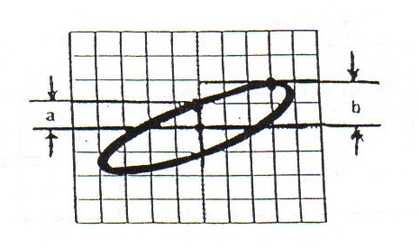

Procedures parts A and B:

The oscilloscope was turned on and the probes were adjusted, then we setup the function generator to create waves of frequencies 1 kHz, 200 Hz and 15 kHz, the vertical sensitivity, horizontal sensitivity, trigger level and trigger slope were recorded. Finally, for the 1kHz, 2volt (p-p) sine wave, the oscilloscope was adjusted to 0.75V on positive slope and 0.5V on negative slope.
Next we proceeded with the three methods for making voltage and time measurements. We followed the instructions on the manual step by step learning how to use the oscilloscope and how to interpret its data.

We continued with the experiment by constructing a circuit of R=500 Ohms, C = 10 nF and we generated a sine wave of frequency of 25 kHz and amplitude of 2V. Next we setup the oscilloscope for AUTOSET, MEASURE with the two different channels connected to the different points of the circuit. We proceed to check for Time Delay Method, Lissajous Figures Method and we observed the results.

We repeated the procedure for other circuits described on the manual for the low pass filter and high pass filters form with RC and RL components. The data obtain of the phase differences, period of waves, peak values at different frequencies were recorded and stored into the data sheet.

After the recorded tables were created and the data was verified to be correct with the theory and the purpose of the circuits, we proceeded to create two types of plots for each of the circuits. The first type of plot was a Gain vs Frequency graph. This graph showed the curve generated by the logarithmic form times 20, which represents the gain in db format. The second graph was a plot of the theta value versus the frequency used in those specific measurements. All the graphs and the data tables are shown below the circuits in the following pages.

Data Obtained Experimentally of each circuit:

Circuit 1 Low Pass Filter
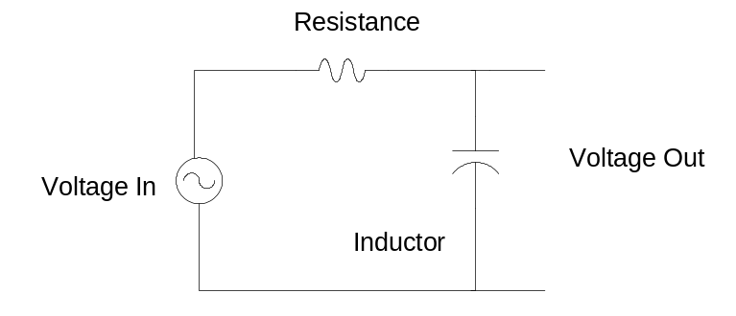
Data Table 1:
 | capacitor
 | f(kHz) | Vin(V) | Vo(V) | T(micro sec) | Td | Vo/Vin | Theta
 | 5 | 2.2 | 2.2 | 200.8 | 8 | 1 | 14.34
 | 15 | 2.24 | 2 | 66.3 | 5 | 0.893 | 27.14
 | 27 | 2.08 | 1.52 | 36.88 | 4.4 | 0.731 | 42.95
 | 28 | 2.04 | 1.52 | 35.8 | 4 | 0.745 | 40.22
 | 29 | 2.08 | 1.48 | 34.58 | 4 | 0.712 | 41.64
 | 30 | 2.08 | 1.46 | 33.56 | 4.4 | 0.702 | 42.9
 | 31 | 2.08 | 1.4 | 32.4 | 4 | 0.673 | 44.44
 | 32 | 2.08 | 1.4 | 31.3 | 4 | 0.673 | 46
 | 34 | 2.04 | 1.34 | 29.4 | 4 | 0.657 | 48.98
 | 35 | 2.04 | 1.32 | 28.56 | 4 | 0.64 | 50.4
 | 36 | 2.04 | 1.3 | 27.59 | 4 | 0.637 | 52.19
 | 42 | 2.04 | 1.18 | 23.84 | 3.6 | 0.578 | 54.36
 | 50 | 2 | 1.04 | 20.04 | 3.6 | 0.52 | 64.67
3db-> | 29,528 | 2.04 | 1.46 | 33.64 | 4.4 | 0.716 | 47.08

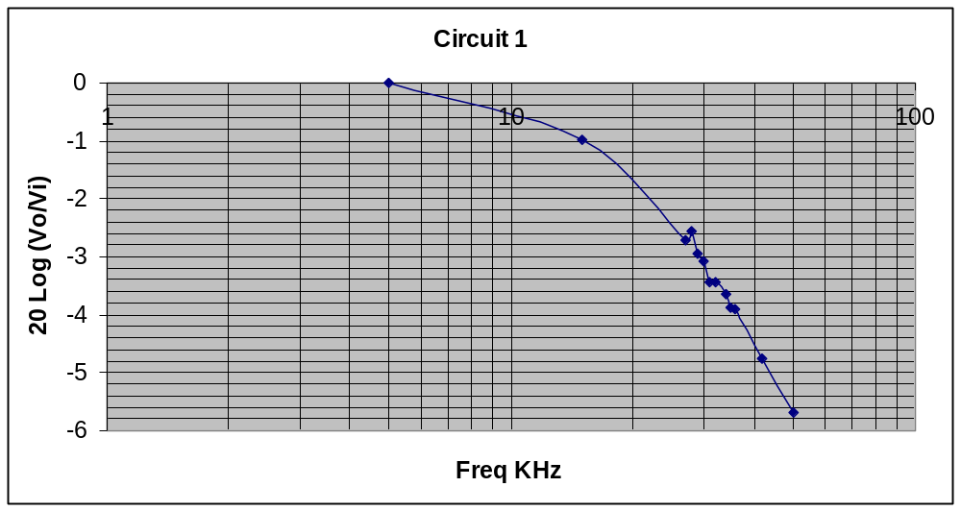
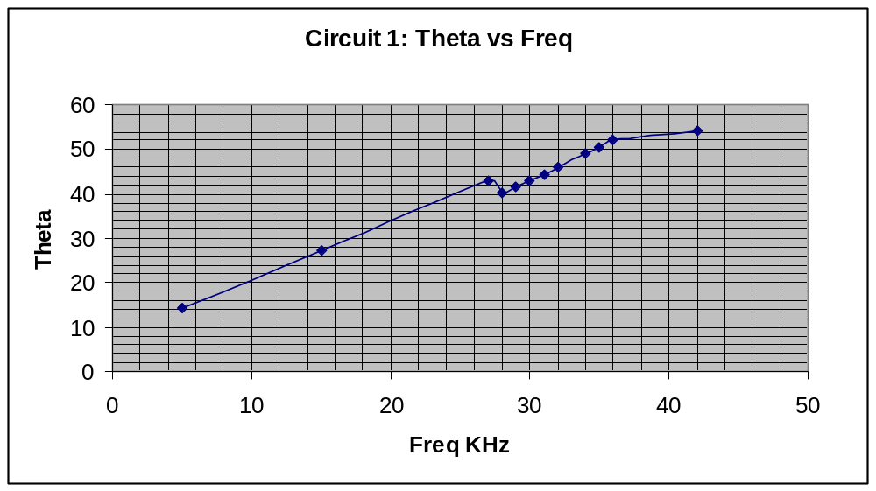

Circuit 2 High Pass Filter
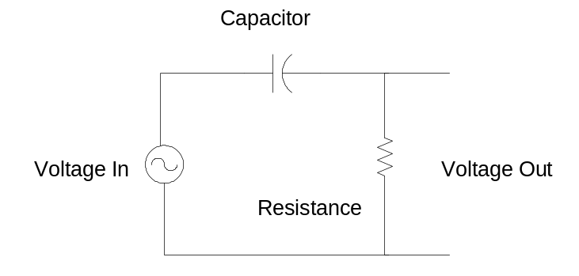
Data Table 2:
 | resistor
 | f(kHz) | Vin(V) | Vo(V) | T(micro sec) | Td | Vo/Vin | theta
 | 50 | 2.04 | 1.72 | 19.92 | 1.6 | 0.843 | 28.9
 | 42 | 2.08 | 1.64 | 24.4 | 2.2 | 0.788 | 32.46
 | 36 | 2.01 | 1.58 | 27.72 | 2.7 | 0.775 | 35.06
 | 35 | 2.08 | 1.56 | 28.56 | 3 | 0.75 | 37.81
 | 34 | 2.08 | 1.54 | 29.36 | 3.2 | 0.74 | 39.24
 | 33 | 2.08 | 1.52 | 30.28 | 3.4 | 0.731 | 40.4
 | 32 | 2.08 | 1.5 | 31.4 | 3.6 | 0.721 | 41.27
 | 31 | 2.08 | 1.5 | 32.2 | 3.8 | 0.721 | 42.5
 | 30 | 2.08 | 1.48 | 33.04 | 4.1 | 0.712 | 44.67
 | 29 | 2.08 | 1.44 | 34.36 | 4.4 | 0.692 | 46.1
 | 27 | 2.08 | 1.4 | 36.9 | 5 | 0.673 | 48.78
 | 15 | 2.16 | 1.0V | 66.5 | 12 | 0.463 | 64.96
 | 4.9 | 2.2 | 392mV | 203.2 | 40 | 0.178 | 70.86
3db-> | 29,528 | 2.08 | 1.44 | 33.96 | 4.1 | 0.692 | 43.46

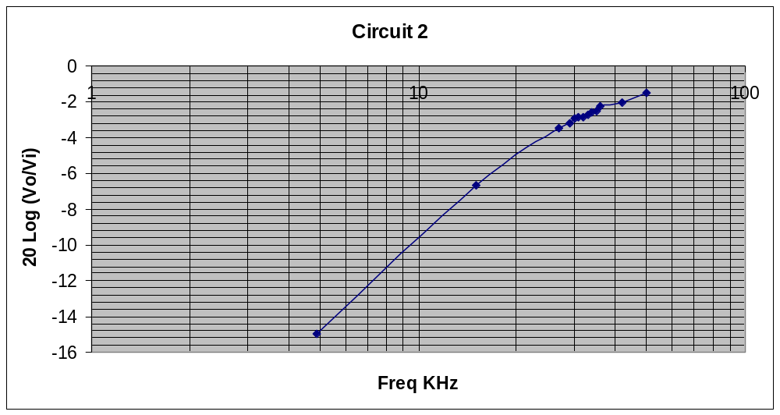

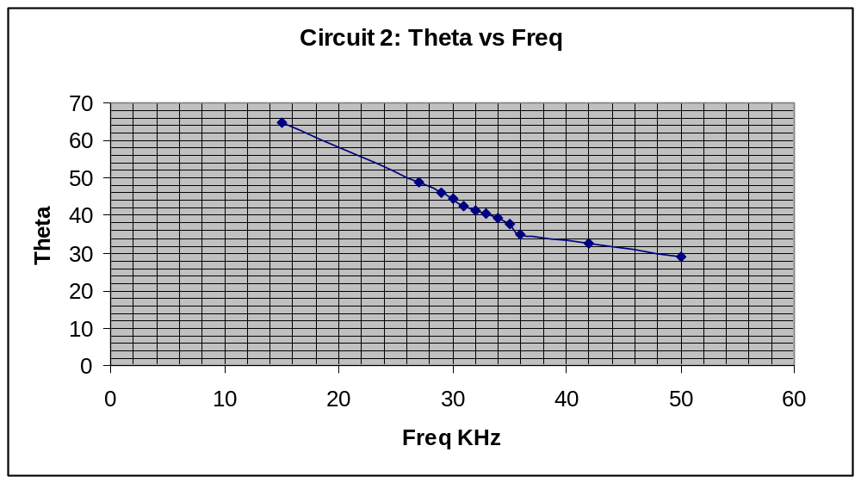

Circuit 3 Low Pass Filter
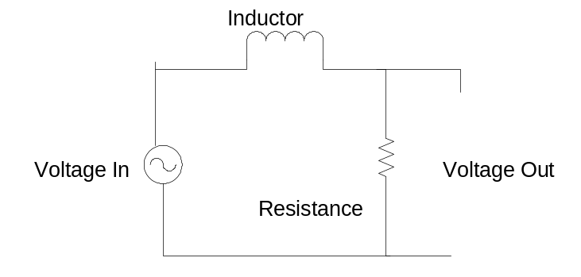

Data Table 3:
 | resistor
 | f(kHz) | Vin(V) | Vo(V) | a | b | Vo/Vin | theta
 | 5 | 9.8 | 9.6 | 0.2 | 1 | 0.98 | 11.54
 | 10 | 9.8 | 9 | 0.4 | 0.9 | 0.918 | 26.39
 | 15 | 10 | 8.6 | 0.45 | 0.8 | 0.86 | 34.23
 | 17 | 10 | 7.7 | 0.45 | 0.8 | 0.77 | 34.23
 | 18 | 10 | 7.5 | 0.5 | 0.8 | 0.75 | 38.68
 | 19 | 10 | 7.3 | 0.5 | 0.8 | 0.73 | 38.68
 | 20 | 10 | 7.2 | 0.6 | 0.8 | 0.72 | 48.59
 | 21 | 10 | 7.12 | 0.6 | 0.8 | 0.712 | 48.59
 | 22 | 10 | 7.04 | 0.65 | 0.75 | 0.704 | 60.07
 | 23 | 10 | 6.88 | 0.7 | 0.75 | 0.688 | 68.96
 | 25 | 10.2 | 6.56 | 0.75 | 0.75 | 0.643 | 90
 | 30 | 10.2 | 6 | 0.75 | 0.75 | 0.588 | 90
 | 35 | 10.4 | 5.52 | 0.68 | 0.7 | 0.531 | 90
3db-> | 22,591 | 10 | 6.97 | 0.67 | 0.75 | 0.697 | 63.3

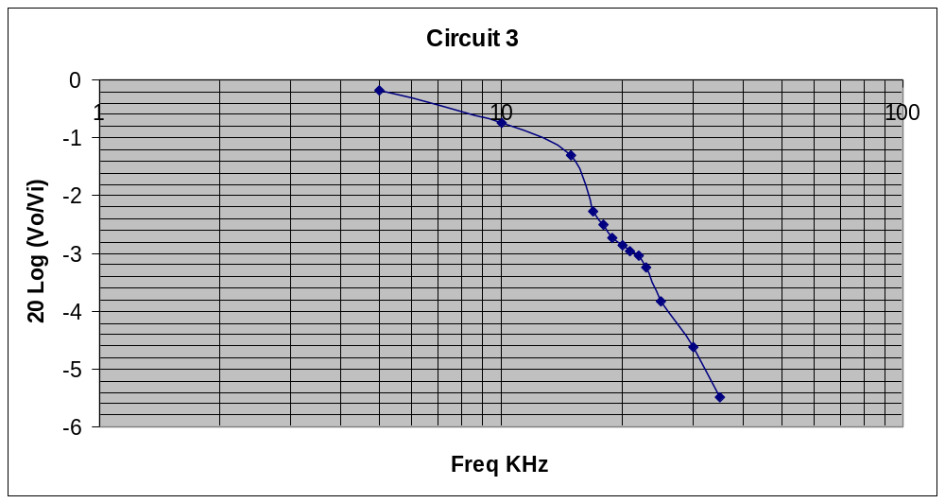
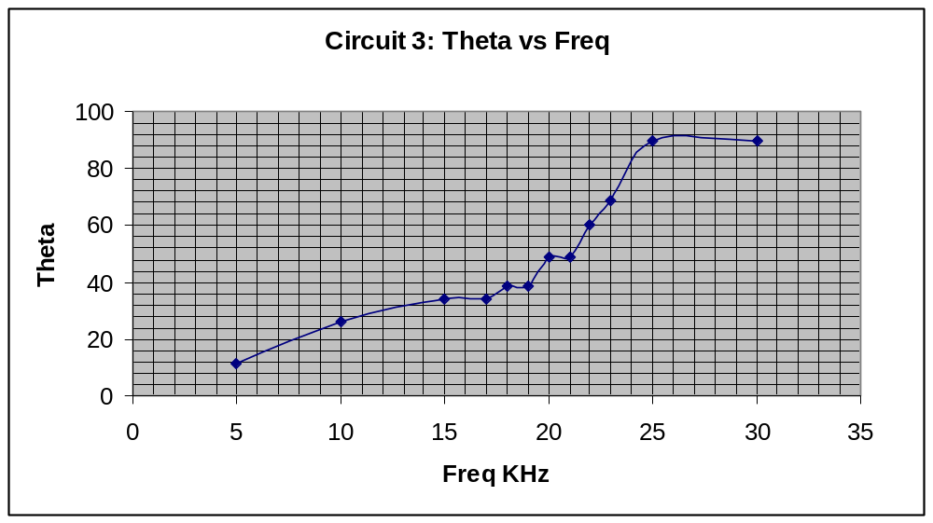

Circuit 4 High Pass Filter
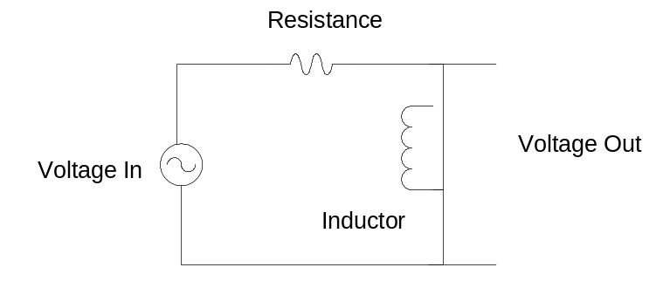
Data Table 4
 | inductor
 | f | Vin | Vo | a | b | Vo/Vin | theta
 | 35 | 10 | 8 | 0.7 | 1 | 0.8 | 44.43
 | 30 | 10 | 7.52 | 0.7 | 0.79 | 0.752 | 62.38
 | 25 | 10 | 6.88 | 0.6 | 0.77 | 0.69 | 51.19
 | 23 | 10 | 6.64 | 0.6 | 0.76 | 0.664 | 52.14
 | 22 | 10 | 6.4 | 0.6 | 0.76 | 0.64 | 52.14
 | 20 | 9.8 | 6.08 | 0.52 | 0.75 | 0.62 | 43.9
 | 19 | 9.8 | 5.92 | 0.51 | 0.75 | 0.604 | 42.84
 | 18 | 9.8 | 5.76 | 0.5 | 0.74 | 0.588 | 42.51
 | 17 | 9.8 | 5.52 | 0.5 | 0.73 | 0.563 | 43.23
 | 15 | 9.8 | 5.04 | 0.49 | 0.66 | 0.514 | 47.94
 | 10 | 9.6 | 3.76 | 0.47 | 0.48 | 0.392 | 78.28
 | 5 | 9.6 | 2 | 0.25 | 0.25 | 0.221 | 90
3db-> | 22,591 | 10 | 6.5 | 0.6 | 0.76 | 0.65 | 52.14

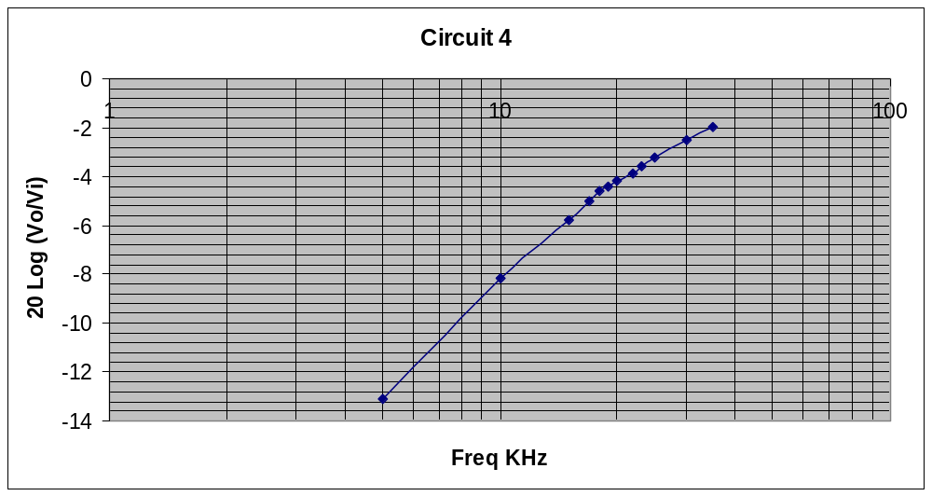

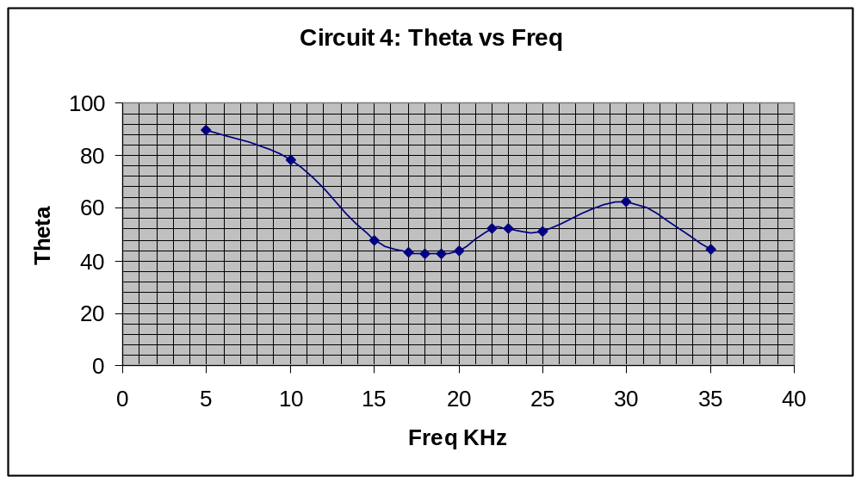

Data Analysis:

The first part of the experiment, that was getting practices in using the oscilloscope and the signal generator, we just followed the instructions on the manual and accomplish all the practice steps to gain experience with the oscilloscope. The most important thing in the first part was the fact that to obtain the measurements of the resistance and the voltage, they could be done by using the oscilloscope or by using the mathematical formulas described in the theory books. However, in that part we didn’t have to calculate much data, but just get used to using the components of the lab and to learn how to interpret the data from the circuits.

In the second part of the experiment, the frequency responses of filters were measured in part 1. We measured the data for the four types of filters and calculated the frequency cutoff and the peak values of the filter. Also we were able to face the correct functioning of the circuit by analyzing the responses of the to the changes of frequencies. In the data sheets we calculated the gain in the table and also the value of theta angle. In part 2, using one of ours birthday as the cut off frequency of a LPF, the calculated frequency was compared with the measured frequency in the data part.
Further in the data analysis, we could conclude that an RL filter is preferable over an RC filter in certain circumstances, for example when the cut off frequency is set and the resistor in front has low resistance compared to the applied voltage. In the other hand, for an RC circuit, where the value of W_{o} = 1 / RC, because capacitor is small when compared to the applied frequency values and the applied voltage, a large resistor is required to obtain the desired results. However, for an RL circuit, when the resistor is has less than 1kΩ, the inductance is pretty small and the cut off frequency goes around high values, in the range of many kilo Hertz.

Conclusion:

In conclusion, the experiment was successful. My partner and I were able to obtain the practices in using the oscilloscope. Also, we understood the idea behind Lissajous Figures and the differences between Time Delay and Lissajous Figures that were used to determine the phase differences. The probes were also used to control the signal going into the oscilloscope. We learn about the operation of the low and high pass filter and the response to these frequencies when using an Inductor or a Capacitor. In summary, all the objectives of the experiment were accomplish and my partner and I have gain greater experience in building analog circuits and analyzing them using the oscilloscope, always backing up the practical experience with the theoretical one.

